Project Design Phase-II Technology Stack (Architecture & Stack)

Date | 15 February 2026
Team ID | LTVIP2026TMIDS83387
Project Name | IntelliSQL: Intelligent SQL Querying with LLMs Using Gemini Pro
Maximum Marks | 4 Marks

Technical Architecture:
The technical architecture of IntelliSQL describes how user queries in natural language are processed, converted into optimized SQL queries using a Large Language Model (Gemini Pro), validated, and executed on relational databases.

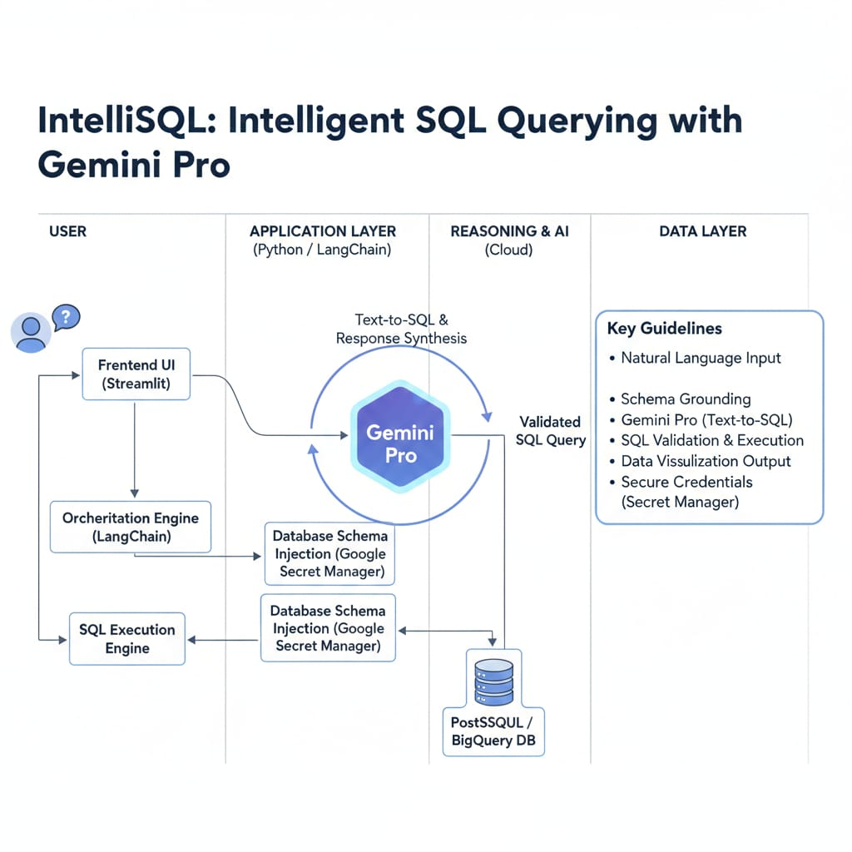

Table-1 : Components & Technologies:
S.No | Component | Description | Technology
1. | User Interface | Web interface where users enter natural language queries and view generated SQL and results | HTML, CSS, JavaScript ,React Js .

2. | Application Logic-1 | Backend logic to process user input and manage API communication | Python (Flask / FastAPI)
3. | Application Logic-2 | Natural Language Processing and SQL generation logic | Gemini Pro API
4. | Application Logic-3 | SQL validation, query execution and error handling | Python
5. | Database | Stores structured relational data used for querying | MySQL / PostgreSQL
6. | Cloud Database | Cloud-hosted relational database service | Google Cloud SQL
7. | File Storage | Stores logs, query history, and system reports | Local File System / Cloud Storage
8. | External API-1 | Converts natural language queries into SQL statements | Gemini Pro API
9. | External API-2 | User authentication and authorization service | Google OAuth API
10. | Machine Learning Model | Large Language Model for Natural Language to SQL conversion | Gemini Pro
11. | Infrastructure (Server / Cloud) | Application deployment and hosting: | Local Server / Google Cloud Platform (GCP).

Table-2: Application Characteristics:

S.No | Characteristics | Description | Technology
1. | Open-Source Frameworks | Frameworks used for frontend and backend development | React JS, Flask / FastAPI
2. | Security Implementations | Secure API communication, user authentication, encrypted data transfer | HTTPS, OAuth 2.0, SHA-256
3. | Scalable Architecture | 3-tier architecture separating UI, logic, and database for easy scaling | Cloud Deployment (GCP), REST APIs
4. | Availability | Ensures high availability using cloud hosting and load management | Cloud Hosting, Load Balancer
5. | Performance | Optimized SQL execution and reduced response time using caching mechanisms | Query Optimization, Caching

